Microsoft Corporation

09
Remote Desktop Load Simulation Test Controller
User Interface Reference
Hammad Butt

Table of Contents
Usage 3
Argument description 3
Controller UI 4
Clients Dialog 6
Server Dialog 7
Config Dialog 8
General Tab 8
Clients Selection Tab 11
Test Progression Tab 12
Script Tab 14
Add Script Dialog 15
Custom Command Tab 16
Configuration File 17
SCALCONTROLLER section 18
AVAILABLESCRIPTS section 19
[script name] section 19

Usage

RDLoadSimulationController.exe [TestConfig.ini] [AutoStart] [CloseAfterTest]

Argument description

- TestConfig.ini – ini file containing configuration details for a single test. This is an optional argument. The test settings can be managed from the UI as well.
- AutoStart – this is an optional argument. If this argument is provided, the test will be launched automatically once the test requirements are satisfied (enough client machines are connected and the server agent is also connected).
- CloseAfterTest – this is an optional argument. This argument will only work with AutoStart. If this argument is provided, the test controller tool will exit once the test run has been completed.

Controller UI

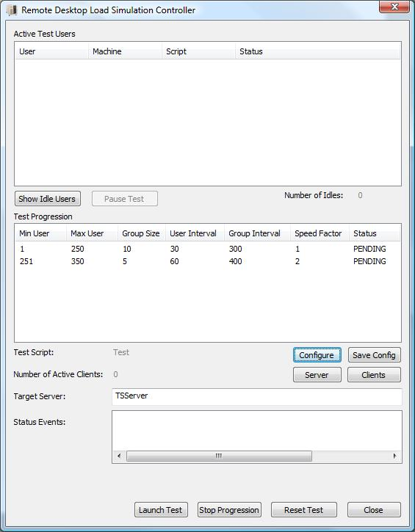
Figure 1

Figure 1 shows the main dialog of the RDLoadSimulationController app. The first list at the top of the dialog shows the current simulated users (or scripts) that are running against the target Remote Desktop server at any given time. This list will start out empty and as new simulated users are launched, they will be added to this list. The second list is the Test Progression which describes the order and schedule of the users to be launched.

Launch Test Button: will start the test according to the current settings

Stop Progression Button: will stop a currently running test progression. This means it will stop launching more user. This will not cleanup or stop the users that are already running.
Save Config Button: will save the current test settings to a configuration file with the name format [Target Server]-[script].ini

Reset Test: will stop the test and reset the controller so that all the current logged on users will be cleaned up. The controller will be in a state where it assumes that no users are logged on so far. Also, the client machines will also clean up and disconnect all users that they are currently running.

Configure Button: opens the Configuration dialog which is described in detail below.

Clients Button: opens the Client machines dialog which is described in detail below.

Server Button: opens the Server machine dialog which is described in detail below.

Show Idle Users Button: opens the Idle Users dialog which lists all the currently running users that have gone idle while waiting for some event.

Clients Dialog

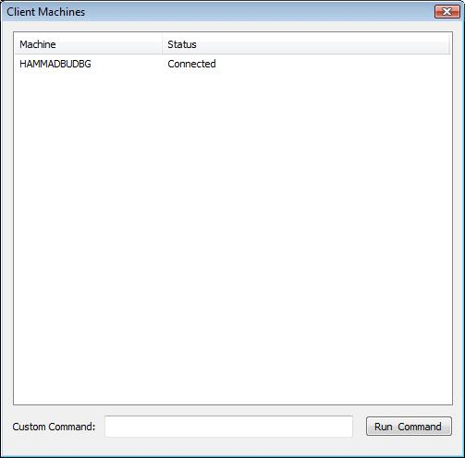
Figure 2

Figure 2 shows the Client Machines Dialog. This dialog shows the list of client machines. It is useful for looking at the client machines status and running commands on the client machines.

Run Command: will run the command in the custom command edit box on each of the client machines that are selected from the list.

Server Dialog

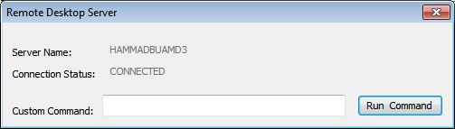
Figure 3

Figure 3 shows the Remote Desktop Server Dialog. This dialog shows the server name and connection status. It is useful for running custom commands on the server machines.

Run Command: will run the command in the custom command edit box on the server machine.

Config Dialog

General Tab

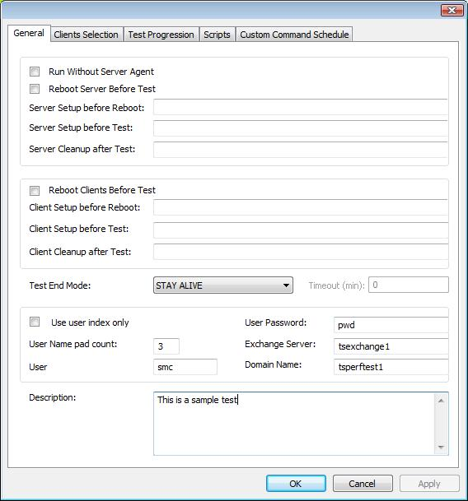
Figure 4
Figure 4 shows the general tab of the configuration dialog. Below is the description of the settings on this dialog:

Check box – Run without server agent: if enabled, this setting means that the server agent is not required for this test and there will be no communication with the server during the test.

Check box – Reboot server before test: if enabled, this setting will make the server reboot before the start of the test and wait for it to come back up before starting the test
Important: the reboot will only work if there is a "Reboot.cmd" script located in the working directory of the server agent or or a location which is in the PATH variable of the server. The Reboot.cmd script should reboot the server.

Server Setup before reboot: this will specify the custom command that will be run on the server before server is rebooted. The script or program has to be in the path of the server agent running on the server. If this setting is specified, the Controller will wait for the command to be executed before continuing. For example, if this setting specifies Test.exe, then the controller will not proceed until the Test.exe has exited on the server. This is true for the below commands as well.

Server Setup before test: this will specify the custom command that will be run on the server before the test is started.

Server cleanup after test: this will specify the custom command that will be run on the server after the test is ended. Useful for collecting logs etc. This is not considered when Test End Mode (below) is “Stay Alive”.

Check box – Reboot client before test: if enabled, this setting will make the clients reboot before the start of the test and wait for them to come back up before starting the test
Important: the reboot will only work if there is a "Reboot.cmd" script located in the working directory of the client agent or the PATH of the client. The Reboot.cmd script should reboot the client.

Client Setup before reboot: this will specify the custom command that will be run on the clients before they are rebooted. The script or program has to be in the path of the client agent running on the client.

Client Setup before test: this will specify the custom command that will be run on the client before the test is started.

Client cleanup after test: this will specify the custom command that will be run on the client after the test is ended. Useful for collecting logs etc. This is not considered when Test End Mode (below) is “Stay Alive”.

Use user index only: this will specify the format of the first argument passed to the script. If checked it will pass only an index to the script which the script will use to construct a username. If unchecked it will pass the whole username to the script.

User name pad count: this controls how many leading zeros will be in the user name. In the example above the first user will be smc001.

User Prefix: specifies the prefix to be used to construct the user names.

User Password: specifies the password that will be used by all users.

Exchange Server: specifies the name of the exchange server if any.

Domain Name: specifies the domain name of the users to be used for login credentials.

Test End Mode: describes when the test is considered to be ended. This has one of the following settings.
- Stay Alive: In this case, it is assumed that the test doesn’t end and more users can be added to the test when all users have been launched.
- Users Finished: Test is only considered finished when all the scripts report back to the controller that they are finished (done using the EndScript method defined below).
- Users Launched: Test is considered finished when all the scripts have been launched.
- Users Launched and Timeout: Test is considered finished when all the scripts have been launched and Timeout minutes have elapsed after the last user was launched.

Timeout: specifies timeout in minutes. This is used with one of the Test End Modes.

Description: used for writing up a test description. This is useful as it is saved in the controller test log.

Clients Selection Tab

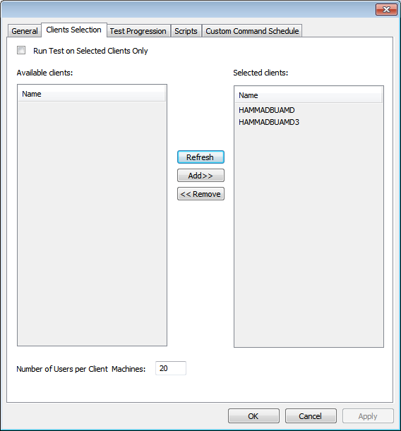
Figure 5

This tab can used to select specific clients on which to run the test. By default the test is run using all available clients. By enabling the checkbox, it is possible to remove some of the clients from the “Selected Clients” list and put them in the “Available Clients” list.

Number of Users per Client Machines: determines how many users will be launched from each client machine.

Test Progression Tab

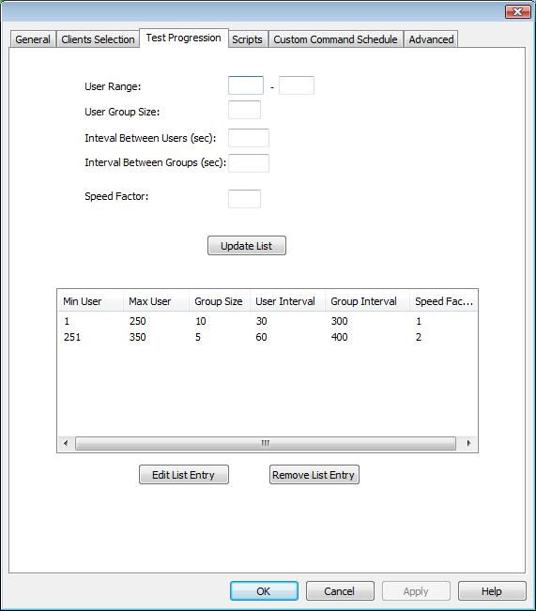
Figure 6

Figure 6 shows the test progression tab. This tab is used to build the test progression list. The use of this list allows us to launch users at different rates through the test. The test will start using the first entry in the list and then it will move to the next entry. Here is description of the various fields in a single progression entry.

- Min User: The index of the first user to be launched.
- Max User: The index of the last user to be launched. For example, if Max User is 100 and Min User is 1, a total of 100 users will be launched.
- Group Size: The number of users in a group.
- User Interval: The number of seconds that the controller waits before starting the next user within the group
- Group Interval: The number of seconds that the controller waits before starting the next group of users
- Speed Factor: Speed Factor is intended to specify how fast the scripts will be run. The scripts will run at the normal speed when the speed factor is set to 1. They will run at double speed when speed factor is 2 – and so on.

Note: This is how the speed factor is supposed to be used. The Controller passes this value to the script on the client machine and it is up to the script how it uses the speed factor. We recommend that any sleeps in the scenario should be reduced based on the speed factor and typing rate should also be adjusted.

Script Tab

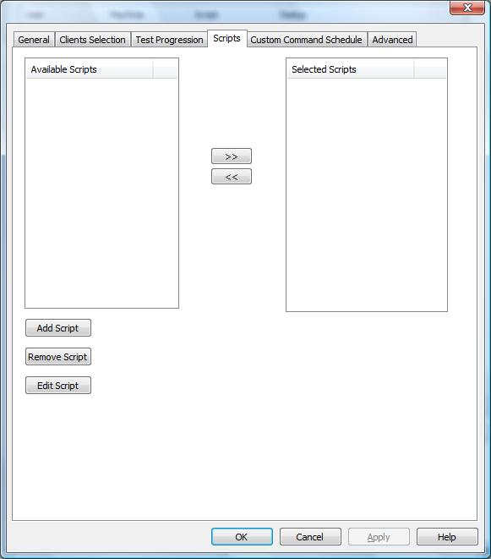

Figure 7

Figure 7 shows the Scripts tab which is used to select the script that will be used for running the test. It is possible to select multiple scripts so that each user will run a list of scripts – one after the other – instead of running only one script. The list of available scripts can be built up by clicking the Add script button. The test will run only the script/scripts that are in the ‘Selected Scripts’ list.

Add Script Dialog

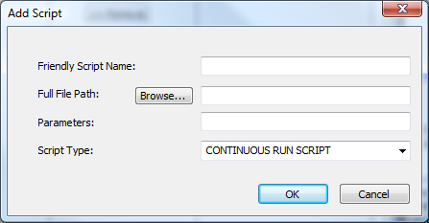
Figure 8

Figure 8 shows the Add Script dialog. This dialog is used to add a new script to the list of Available scripts. Below is the description of the settings on this dialog:

Friendly Script Name: this can be any friendly name given to the script. it does not have to match the file name

Full File Path: Full file path of the script file. This setting can be typed in. Alternatively, you can use the Browse button to select the script file.

Parameters: optional parameters to be passed to the script. This can be left empty if no optional parameters are required

Script Type: is not used currently

Custom Command Tab

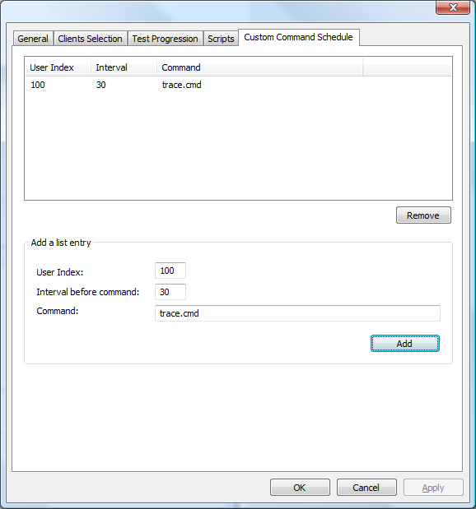
Figure 9

This tab is used to specify custom commands that will be run based on user load events. In the figure above, the entry in the list specifies the following: when user 100 is launched, wait for 30 seconds and then run trace.cmd on the server machines. There can be multiple commands specified in this list.

Configuration File

Below is a sample configuration file that can be passed to the controller

[SCALCONTROLLER]
UserIndexMode=0
ServerAgentMode=1
TClientMode=0
RebootServerMode=0
RebootClientMode=0
UserPadCount=3
UsersPerMachine=20
TestEndMode=2
CommandTimeout=5
TestEndTimeout=0
UserPrefix=smc
UserPassword=pwd
DomainName=Tsperftest1
ExchangeServer=TSExchange1
ServerName=TestServer
ServerPreRebootCommand=ServerPreReboot.cmd
ServerPreTestCommand=PrepareServerForTest.cmd
ServerTestCleanupCommand=ServerTestCleanup.cmd
ClientPreRebootCommand=ClientPreReboot.cmd
ClientPreTestCommand=PrepareClientForTest.cmd
ClientTestCleanupCommand=ClientTestCleanup.cmd
TestDescription=Type test description here;
ProgressionListCount=1
Progression1=1-200-10-30-300-1
CommandListCount=1
CommandEntry1=100-30-trace.cmd
ScriptListCount=1
ScriptName1=Test.vbs
[AVAILABLESCRIPTS]
ScriptsCount=1
ScriptName1=test.vbs
[test.vbs]
filepath=c:\temp\test.vbs
parameters=params
type=3
Some of the settings are self explanatory. Below is the description for the ones that are not.

SCALCONTROLLER section

UserIndexMode: this will specify the format of the first argument passed to the script. If set to 1 it will pass only an index to the script which the script will use to construct a username. If 0 it will pass the whole username to the script.

TClientMode: Set to 0 and ignore.

ServerAgentMode: this will determine whether to use the server agent during the test. If set to 0 the server agent will not be required for the test and there will be no communication with the server during the test. If set to 1, server agent will be required for the test.

UsersPerMachine: This setting will control how many scripts will be launched on each client machine.

CommandTimeout: This is the time in seconds that the controller will wait after running the server and client commands like ServerPreRebootCommand etc.

TestEndMode: This determines how the test is considered ended. The cleanup jobs are run on the server and client machines only when the test is considered ended by the controller. There are 3 values for this setting
- 0 – Stay Alive mode. After launching the last user, the controller does nothing. More users can now be added to the progression list and the test may continue.
- 1 – Users Finished mode. In this mode the test is considered ended only after all the launched scripts report back telling the controller that they have ended (this is done using the EndScript() method exposed by the DCOM object)
- 2 – Users Launched mode. In this mode the test is considered ended once all the scripts have been launched and the controller has waited for the time specified by the last group interval.
- 3 –Users Launched and Timeout. Test is considered finished when all the scripts have been launched and Timeout minutes have elapsed after the last user was launched.

ProgressionListCount: has the number of entries in the progression list. If this is set to 2, the ini file must have the entries Progression1 and Progression2.

Progression1: has the settings for the first entry of the progression list in the following format.
[first user]-[last user]-[group size]-[user interval]-[group interval]-[speed factor]

CommandListCount: has the number of entries in the custom command list. If this is set to 2, the ini file must have the entries CommandEntry1 and CommandEntry2.

CommandEntry1: has the settings for the first entry of the custom command list in the following format.
[user index]-[interval to wait]-[command]
The command will be run on the server after the user with [user index] is started
[interval to wait] is the interval in seconds to wait before running command
The script or program has to be in the path of the server agent running on the server

ScriptListCount: has the number of entries in the script list. If this is set to 2, the ini file must have the entries ScriptName1 and ScriptName2 in this section. This should be set to 1 if only one script is needed to be run for the test.

ScriptName1: specifies the name of the script (example: Test.vbs) to be run. This must be one of the scripts listed in the AVAILABLESCRIPTS section.

AVAILABLESCRIPTS section

This section describes the scripts available to choose from for this test. Think of it as the script library.

ScriptCount: has the number of entries in the available script list. If this is set to 2, the ini file must have the entries ScriptName1 and ScriptName2 in this section. This should be set to 1 if only one script is available.

ScriptName1: specifies the friendly name of the script (example: Test.vbs). There must be a section in the INI file with this name.

[script name] section

In the above example, the section is [Test.vbs]

Filepath: Full file path of the script.

Parameters: optional parameter to be passed to the script. This can be left empty if no optional parameters are required

Type: is not used currently

